Summer Intern Program
Post-orientation communication
June 2025

Jetnet – June 9

American invests in its future with new class of summer interns
Description/subhed: American’s newest class of summer interns have arrived and they’re here to contribute.
Images:
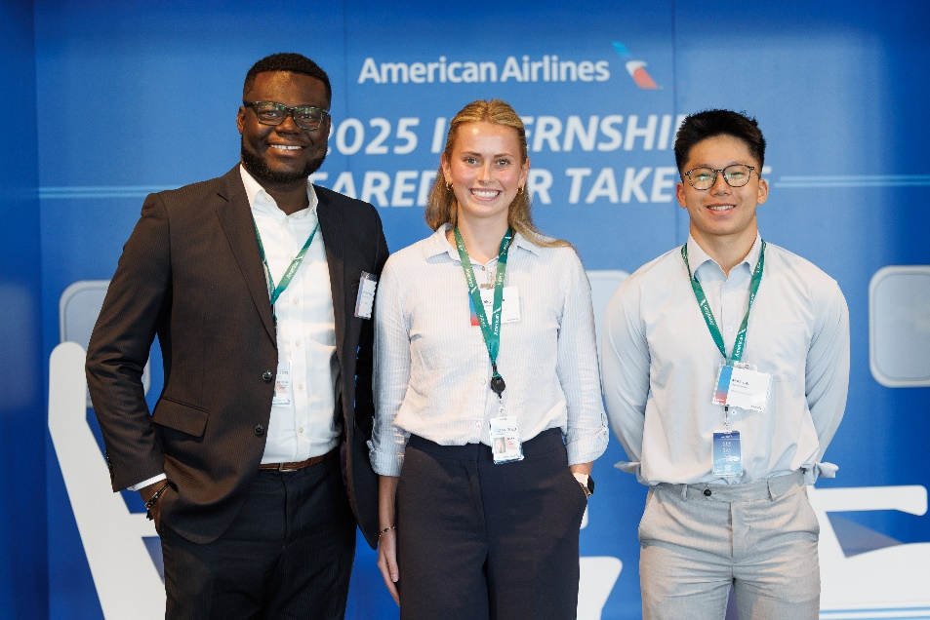
Caption: From left: 2025 summer interns Patrick Botchwey, Riley Raynor and Mark Tran.
By Ralph Evans
Nearly 200 college students traded in textbooks for team briefings last week as American kicked off its 2025 summer internship program. The airline welcomed students from across the U.S. and around the world for a 10-week experience aimed at building skills, making connections and introducing a new generation to careers in aviation.
Interns gathered June 2–3 at American’s Robert L. Crandall campus in Fort Worth for a two-day orientation featuring executive panels, team-building activities and a deep dive into the airline’s operations. It marked the start of what leaders hope will be a meaningful, purpose-driven summer.
“It’s not just about work experience — it’s about giving these students a sense of what it feels like to be part of something bigger,” said Terrence Bradshaw, Director, Commercial Recruiting and Campus Programs. “They’re not here to observe. They’re here to contribute.”
And contribute they will. The interns are embedded in more than 40 departments, from corporate finance and HR to fleet planning and technology. Many bring backgrounds that are as diverse as the airline’s global reach.
Mark Tran, a student at Texas Christian University, knows a thing or two about long journeys. Born in Bac Ninh, Vietnam, he studied through the pandemic while juggling time zones and coursework across continents. Now working in the airline’s Corporate Purchasing unit, he says he’s excited to “see the behind-the-scenes work that connects people and cultures.”
Patrick Botchwey, an MBA candidate at Duke University, brings a different perspective. Originally from Ghana, Patrick left a leadership role in West Africa to pursue graduate school in the U.S. Now supporting the Fleet Planning team, he’s eager to apply his finance skills to real-world challenges in an industry that helped shape his own journey.
And then there’s Riley Raynor, a University of Kansas student with a passion for wellness and a family history rooted in aviation. She once “flew” a small aircraft as a child, with a little help from her Marine Corps pilot dad.
Team members can spot the interns by their green lanyards and are encouraged to say hello, offer guidance or even swap a few travel stories.
After all, these students aren’t just visiting for the summer. They’re helping shape American’s future.

